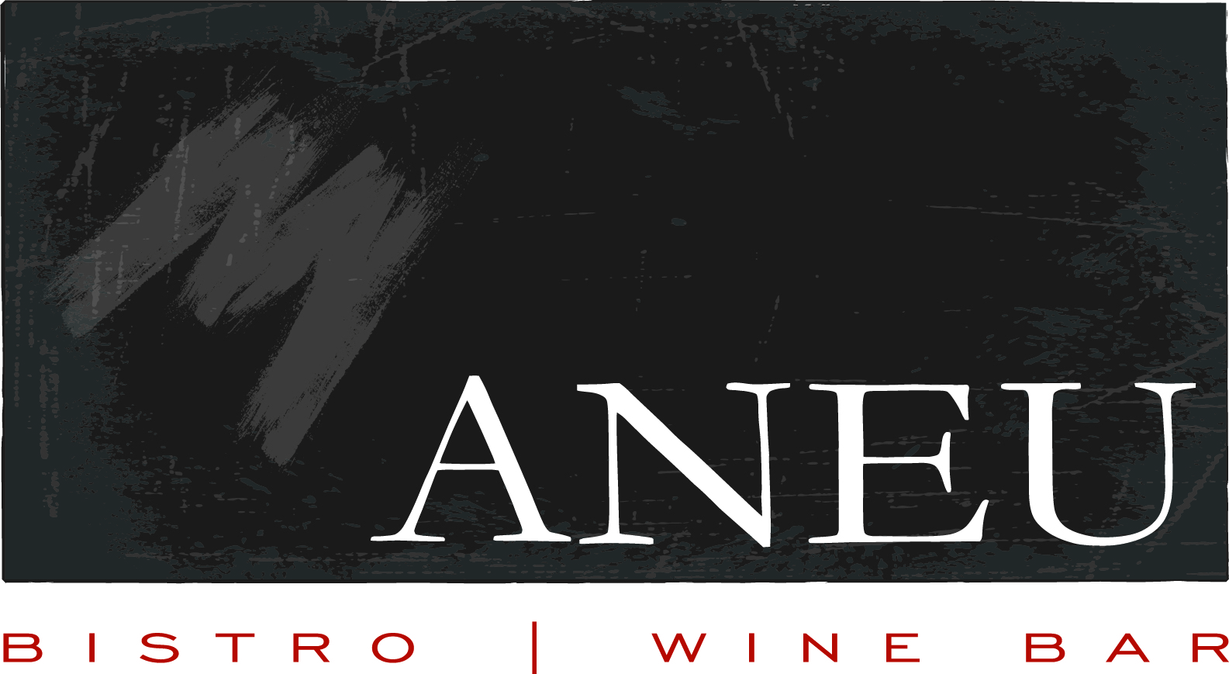
Bar Menu

Raw Oysters
raw oysters on the half shell by the half dozen
market price
Crab Cake Sliders
house made mini crab cakes, brioche buns, lemon garlic aioli
12
Short Rib Quesadillas
slow roasted beef, grilled flour tortilla, arugula, goat cheese, dried cherries, jalapeño sauce
11
Truffle Fries
shoestring fries, truffle, parmesan, parsley
9
Steamers (Clams & Mussels)
chorizo sausage, carmelized onion, garlic, fresh herbs, white wine
10
Cheesesteak Spring Rolls
siracha crema
8
Calamari
seasoned calamari, peppers, onions, zucchini
10
Zucchini Fries
buttermilk ranch, roasted red pepper aioli
9
Mediterranean Plate
hummus, olives, dolmas, feta, grilled pita
10
Artisan Cheese Display
three seasonal cheeses, crostini, assorted relishes
15

Bar Menu

Raw Oysters
raw oysters on the half shell by the half dozen
market price
Crab Cake Sliders
house made mini crab cakes, brioche buns, lemon garlic aioli
12
Short Rib Quesadillas
slow roasted beef, grilled flour tortilla, arugula, goat cheese, dried cherries, jalapeño sauce
11
Truffle Fries
shoestring fries, truffle, parmesan, parsley
9
Steamers (Clams & Mussels)
chorizo sausage, carmelized onion, garlic, fresh herbs, white wine
10
Cheesesteak Spring Rolls
siracha crema
8
Calamari
seasoned calamari, peppers, onions, zucchini
10
Zucchini Fries
buttermilk ranch, roasted red pepper aioli
9
Mediterranean Plate
hummus, olives, dolmas, feta, grilled pita
10
Artisan Cheese Display
three seasonal cheeses, crostini, assorted relishes
15

