Update from capozzi camp. The photo below is of Barbara cleaning up Kenyatta's block (1800 Block of Manton St) - more photos of this here - one of the filthiest blocks in the City - where he lives. Barbara is ready to clean the campaign up with a WIN, and the City too.
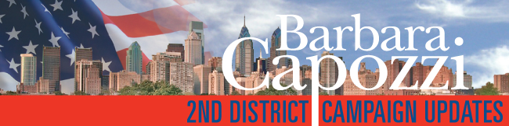
DEAR LOYAL SUPPORTERS,
The Second Council primary race is 'too close to call' with only a handful of votes separating me from my main opponent. The final results are not in yet and all legal measures will be taken to ensure that the Second Council District has the honest representation that it so deeply deserves. I am extremely proud of the honest, clean campaign that we and our many supporters waged. Your hard work and efforts have been truly inspirational during these last final moments before the decision is aired.
We are optimistic for a positive outcome, and have hired two attorneys to oversee the final vote count process including absentee ballot count. The final results may not be decided for at least another week. We are collecting information regarding any observations of irregularities at the polls. Please send an email of details, time, place and description of any abnormal activity you experienced in the 2nd District to bc@capozziforcouncil.com.
We are asking for your help to raise funds to see the campaign through to victory. We vow to continue to ensure a fair election process for the people of the Second District. Please consider donating online for the very last time, to see this through to a win!
Thank you for your support as always, and let's win this thing!
Barbara Capozzi

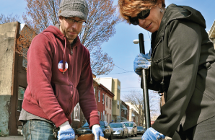 |  | STAY UPDATED
To stay up to date with Barbara, and the election feel free to check our website and social platforms.
Website - Facebook - Twitter
Recent News:
Philadelphia Inquirer
Newsworks

 | Capozzi For Council Campaign Office  2504 S. Broad Street Philadelphia PA 19145  Email: info@capozziforcouncil.com  Phone: 267-888-6045  PAID FOR BY CAPOZZI FOR COUNCIL |  | 

