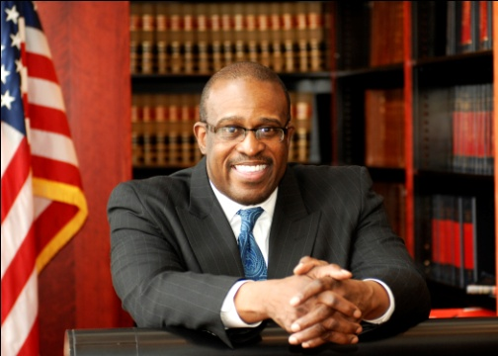

FOR IMMEDIATE RELEASE CONTACT:
June 14, 2011 Ben Eisenberg (610) 574-8024

Judge Jimmie Moore Begins Campaign for Congress
Will Formally Announce His Run in July
PHILADELPHIA, PA— On Monday, June 6, Judge Jimmie Moore filed paperwork with the Federal Election Commission to begin the process of his candidacy to represent Pennsylvania’s First Congressional District in the United States House of Representatives.
"Over the coming weeks, I will continue to build my team and travel around the district talking to residents about the issues they find most pressing, and in July, I will formally announce my campaign for Congress to bring the change that our district desperately needs," Moore said. "Washington is out of touch with what's happening to our families and communities. Special interests have more power than the people. Just like a young community organizer from Chicago, I have hope, a vision, and a belief in giving back and helping others."
Growing up in federal housing projects and living on welfare, Moore learned firsthand about the struggles of inner-city life. After becoming the first person in his family to graduate from college he earned a master’s degree in Urban Education and a subsequent J.D. from Rutgers University School of Law. Since then, Moore has lived in the Philadelphia area, raising his two children and practicing law for almost four decades.
For the past 12 years, Judge Jimmie Moore has served on Philadelphia’s Municipal Court. He founded and directed a community-based diploma program to give underemployed people and ex-offenders a chance to become legal secretaries and paralegals, turning tax-takers into taxpayers. Judge Moore is committed to developing “green-collar,” environmentally friendly, sustainable jobs for the residents of PA-01.
For more information, please visit www.jimmiemoore.com
# # #

