University City District is issuing this request to secure mobile food vendors that provide unique, high-quality and sustainable food options that fit the highly mobile and urban environment of The Porch. Selected vendors will be asked to vend once a week for one month.
Respondents must return this proposal with all required documentation and attachments by
5pm on Thursday February 22nd, 2013 to:

Lori Klein Brennan
University City District
3940 Chestnut Street
Philadelphia, PA 19140

1. The Porch
The Porch is a new outdoor public space in University City. Located next to the country’s second busiest train station, several major employment centers and a stone’s throw from UPenn and Drexel, it is a vibrant and welcoming gateway to the City of Philadelphia. The Porch is a place of activity, respite, and social interaction with magnificent views of the Schuylkill River and the Center City skyline.

Since the space opened in November, 2011 there have been several hundred events held at The Porch – all free to the public. With 200 seats in 0.7 acres of open space, The Porch currently attracts 1000 active users per day in the warmer months. At the epicenter of over 17,000 employees and adjacent to a transit hub serving 37,000 passengers a day, we anticipate this number will only continue to grow.

Research that has been conducted at The Porch reveals that one of the top things people want more of is access to food. For that reason UCD has engaged versatile and innovative food vendors to fill four spots during lunchtime at The Porch. In its inaugural year, this vending was a success and the 2-4 trucks we had each week combined sold upwards of 250 tickets in a three hour sitting.

For its second season, UCD seeks mobile food vendors that provide unique, high-quality and sustainable food options that fit the highly mobile and urban environment of The Porch. Respondents should be interested in partnering with UCD to promote and activate The Porch and must be able to commit to either a Wednesday or Friday each week and commit to an entire month. They must also have all necessary permitting and licensing required to vend in the City of Philadelphia and should be able to indemnify UCD on their insurance policy (see Appendix for a complete list of required documentation).

2. Mobile Food Vending Details
The Porch
The Mobile Food Vending at The Porch season will begin on Wednesday April 3rd and last until the end of November, 2013. There will be two vending days, 11:30 am – 2:30 pm Wednesday and Friday. Respondents will be selected to vend on either a Wednesday or Friday for at least four consecutive. Initially, vendors will be selected for the months of April, May and June.

There will be no cancellation of vending days due to inclement weather, vendors are encouraged to vend in all conditions and fees will not be refunded should they choose not to show up. While we will secure your truck/cart a spot on The Porch, it is important to note that no additional parking cars will be provided for vendors. There are several lots in the area. 5 Star Parking at 3051 John F Kennedy Boulevard, Philadelphia Parking Authority at 3101 Market street and the Cira Center at 2929 Arch Street are nearby options.

The following is a picture of The Porch with spaces for vending indicated by arrows:

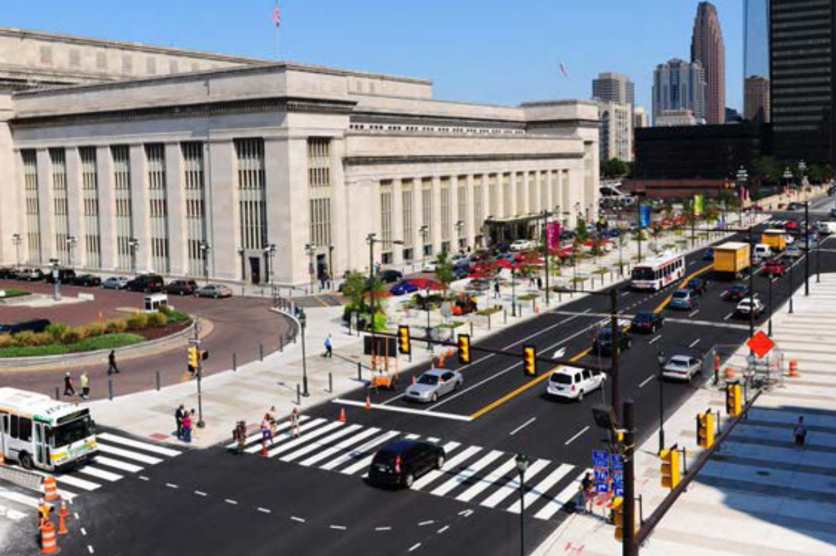
Vending Locations
Vending Locations

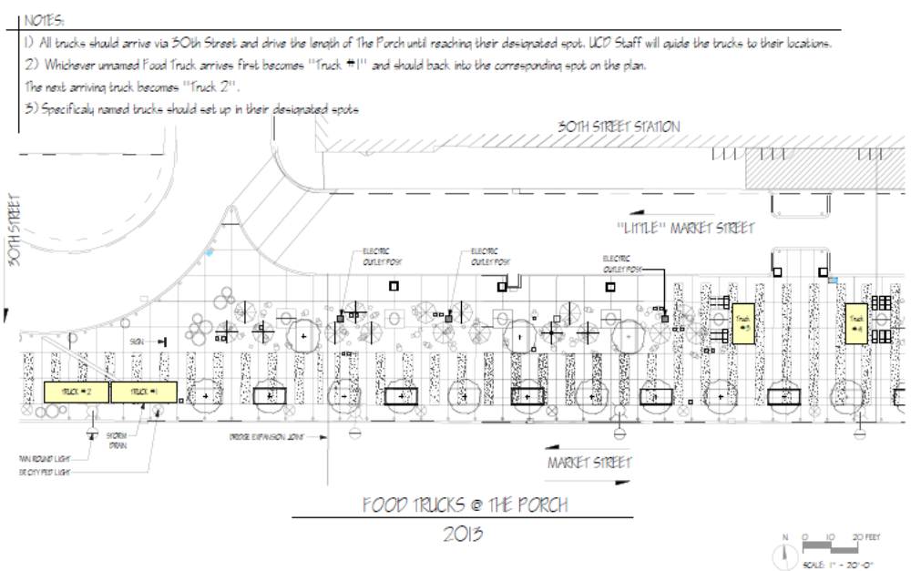
The Vendors
Selected vendors will be assigned a spot to vend. The Porch has roughly 0.7 acres of open space. It is separated into ten “rooms” by benches, planters and other street furniture. Movable chairs and tables are supplied throughout the spaces and loungers are even available in the Meadow (the central section). Concentrations of pedestrians are seen on the edges of the site and in the center. Most visitors tend sit and eat between these two sections.

Preference will be given to respondents who offer high-quality, affordable, interesting and sustainable food options, especially those that are fitting of the site, location and lunch time slot. Respondents with a demonstrated history of providing exceptional will also be prioritized.

The Cost
Vendors will be asked to pay a $35 daily concession fee. This must be paid in advance of vending to University City District. Selected applicants will be required to pay in advance of vending by check for entire month.

3. Respondent’s Proposal
Respondent Information
Owner Name
Business Name
Street Address
City, Zip
Work Phone
Cell Phone
Email Address
Business Website

Food Truck/Cart Information
Please attach the following items and information:
- Food Truck/Cart menu with prices
- Two photos of Food Truck/Cart from different vantage points
- Proof of respondent’s business and address

Vending Schedule
Please rank your vending month in order of preference (1 being greatest, 3 being least):
April Not Available Wednesday OR Friday
May Not Available
June Not Available

Qualifications
Use the box below to highlight your Food Truck/Cart’s success (e.g. events vended at, number of employees, average tickets per hour, or, if new, description of product and what makes it appealing to customers).

If selected, I agree to pay University City District $140 per month ($35 per vend day) Yes No

By signing below, the respondent confirms that they have read the Request for Proposals for Food Trucks at the Porch and agrees to comply with the rules and practices outlined within.

Signature of business owner: ________________________________________ Date: _______________
4. Reservation of Rights and Mandatory Conduct
University City District reserves the right to reject any respondent’s proposal on the basis that it is incomplete, does not satisfy the qualifications set forth in this document or is otherwise not in the best interest of the Mobile Food Vending program at The Porch.

University City District also reserves the right to ask any respondents to interview, answer additional questions or provide additional information as part of the application process.

Additionally, once selected, University City District reserves the right to discontinue vendors’ participation in the Mobile Food Vending program at The Porch at its own discretion. Should any of the following standards not be met a vendor’s participation in the program may be discontinued:

A. Food Safety Certification
All vendors must have at least one employee present who:
Attended a Food Safety Certification Course
Obtained a formal Food Safety Certification document from the Philadelphia Department of Public Health

Further, all vendors themselves, regardless of whether they operate food trucks/carts, should obtain Food Safety Certification.

B. Inspection
Vendors may be subject to random inspections from Licenses and Inspections of Philadelphia and should act professionally and allow the Inspector to conduct his or her inspection.

C. Licensing
Required licenses should be available for viewing upon request from any vendor. Furthermore, should any license expire during the season of vending, University City District must be furnished with a copy of the new up-to-date license.

D. Truck/Cart Upkeep
In addition to meeting the City of Philadelphia Department of Public Health standards, all vendors must maintain a clean and safe facility at all times and the following standards should be met:
- Trucks should not have any potentially hazardous leaks or emit any unusual or noxious gases
- Carts must be securely attached to vehicles when in transit
- Trucks operating as free-standing vehicles should be inspected to satisfy all Department of Motor Vehicles and transportation-related laws and regulations

E. Insurance
All vendors should obtain proper insurance for their businesses. Such insurance coverage may include:
- Commercial Liability Insurance
- Employment/Workers’ Compensation Insurance
- Fire Insurance
- Automobile Insurance

F. Vendor Behavior
All vendors must act professionally to each other at all times. Beyond maintaining an appropriate level of professional courtesy, vendors must:
- Promote their Food Trucks/carts at The Porch vending through all social media outlets
- Only vend at assigned vending location
- Do no harm to or seek to negatively impact the business of fellow vendors
- Not use social media or other marketing sources to disparage other vendors

5. Instructions

To submit an application for mobile vending at The Porch, respondents must complete section 3. “Respondents Proposal” including required attachments and return it by mail with all required documentation (as describe in the Appendix) to:

Lori Klein Brennan
University City District
3940 Chestnut Street
Philadelphia, PA 19140

by 5pm on Thursday, February 22nd.

Appendix

Licensing and Insurance Requirements
The following list of licenses, permits, and regulations for the convenience of potential respondents to the RFP. It is not a guarantee that this list is complete. Additional licenses, permits, and regulations may apply. It is recommended that a respondent confer with a private attorney to ensure the respondent complies with all Applicable Laws, including licensing and permitting requirements.

Sections 1 – 6 must be completed and documentation of each must be submitted with respondent’s proposal.

1. Business Privilege License
All Vendors are required to obtain a Business Privilege License. For more information please visit: http://www.phila.gov/li/ContentPage.asp?TopNode=services&level1=49&level2=50&level3=

2. Mobile Food Vending Program - Department of Health
All Vendors must review and adhere to the Mobile Food Vending Program of the Department of Health. For more information about the Mobile Food Vending Program, please visit:
http://www.phila.gov/health/pdfs/Mobile_Vending.pdf

3. Food Safety Certification Program - Department of Health
All Vendors interested in serving prepared or cooked foods and drinks must acquire a Food Safety Certificate. For more information about the Food Safety Certification Program, please visit:
http://www.phila.gov/health/pdfs/Food_Safety_Cert_Insturct_App_7-10.pdf
For a list of Food Safety Certification training courses in the City, please visit:
http://www.phila.gov/health/pdfs/Food_Safety.pdf

4. Mobile Food Vendor Certificate of Eligibility - Department of Health
Upon completion of the Food Safety Certification Program, Vendors, in order to receive a Mobile Food Vendor Certificate of Eligibility, must visit the Department of Health to have their Vending Unit inspected and secure a commissary or support facility for food and cleaning supplies. The Department of Health will request proof of the Vendor’s use of the commissary or support facility.

5. Food Establishment. Retail Non-Permanent Location License - Department of Licenses and Inspections
Vendors must present the Department of Licenses and Inspections documentation of their Business Privilege License and Mobile Food Vendor Certificate of Eligibility to obtain a Food Establishment, Retail Non-Permanent Location License. The additional requirements listed below may apply as well:
a. if a business is operated from a motor vehicle, the Vendor must obtain a Motor Vehicle License; or,
b. if a business is operated from a tent or canopy measuring over 100 square feet, the Vendor must obtain a permit for the tent or canopy. For more information please visit:
http://www.phila.gov/li/ContentPage.asp?TopNode=services&level1=49&level2=214&level3=235

6. Insurance Requirements
Once selected vendors shall, at their sole cost and expense, obtain and maintain the types and minimum limits of insurance coverage specified below. The Vendor shall procure all the required insurance from reputable insurers who are acceptable to the City and authorized to do business in the Commonwealth of Pennsylvania. The Vendor shall cause the insurance to provide for at least 30 days prior notice be given to the University City District in the event coverage is materially changed, cancelled, or non-renewed. The Vendor shall cause all insurance required below to be written on an “occurrence” basis and not a “claims-made” basis.

A. Workers' Compensation and Employers’ Liability
i. Workers Compensation – Statutory Limits;
ii. Employers Liability:
$100,000 Each Accident - Bodily Injury by Accident;
$100,000 Each Employee - Bodily Injury by Disease;
$500,000 Policy limit - Bodily Injury by Disease;
iii. Other states endorsement including Pennsylvania.

B. Commercial General Liability Insurance
i. Limit of Liability: $1,000,000 per occurrence combined single limit for bodily injury (including death) and property damage liability; $1,000,000 personal and advertising injury; $2,000,000 general aggregate.
ii. Coverage: Premises operations; blanket contractual liability; personal injury liability; products and completed operations; independent contractors; employees and volunteers as additional insureds; cross liability; broad form property damage (including completed operations) liability.

C. Commercial Automobile Liability Insurance
i. Limit of Liability: $1,000,000 per occurrence combined single limit for bodily injury and property damage liability;
ii. Coverage: Owned, hired and non-owned vehicles.

D. The Vendor shall cause University City District to be named as additional insured on the General Liability policy. Also, the Vendor shall obtain endorsements which state that the coverage afforded the City as additional insured will be primary to any coverage available to it.

7. Agreement – University City District
Completion of Sections 1-6 of the Licensing Requirements described above and the award of a Vending Location by University City District will result in the issuance of the Agreement with University City District.

